**Joseph Peeler Snider ? Snyder? and Maggie Lee Hickey ?**

  
[Save](http://trees.ancestry.com/pt/ViewPhoto.aspx?pid=&tid=3364832&pg=39,21&tl=1&oid=a33253d4-9c3c-4aee-8562-7f30001f90d9&idx=174#Current) or [Cancel](http://trees.ancestry.com/pt/ViewPhoto.aspx?pid=&tid=3364832&pg=39,21&tl=1&oid=a33253d4-9c3c-4aee-8562-7f30001f90d9&idx=174#Current)

*Added by* [*sylviarnmlt*](http://www.ancestry.com/community/member/profile.aspx?cba=sylviarnmlt) *on 23 Mar 2008*

[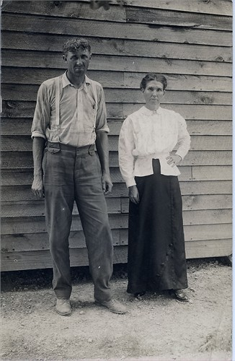](javascript:openOriginalPhoto())

Joseph Peeler Snider 1877-1945 and Maggie Lee Hickey 1875-1937?