[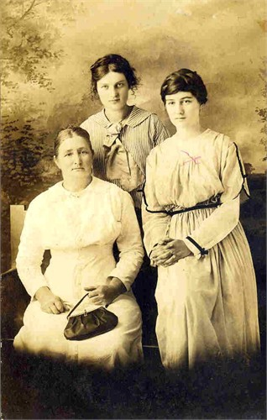](javascript:openOriginalPhoto())

Left is Viola Belle Nichols Snider, middle-Gertrude Wagner Snider, and right Ida Snider