[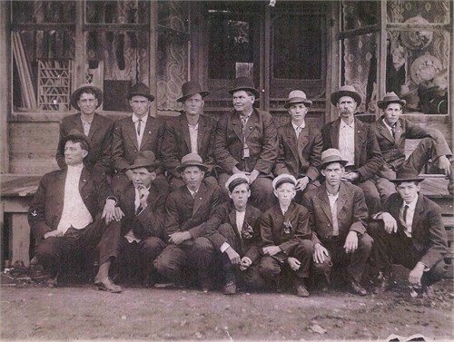](javascript:openOriginalPhoto())

Top row left to right: 1: unknown 2. unknown 3. C.E. Ramsey (Jenne L. says 3rd from left,top row is Charles Cicero Clay) 4. Spence Hedgepeth 5. Levi Wesley Snider(is 3rd from the RIGHT, top row) 6. unknown 7. Tom Hedgepeth. Bottom Row, left to right: 1. unknown 2. James Hedgepeth 3. Oscar Hedgepeth 4. "Loyal Bunker "Bunk or Buck" Greene 5. Friend Bossier "Boss" Greene 6 Charles Clay 7. Preston Snider (?)