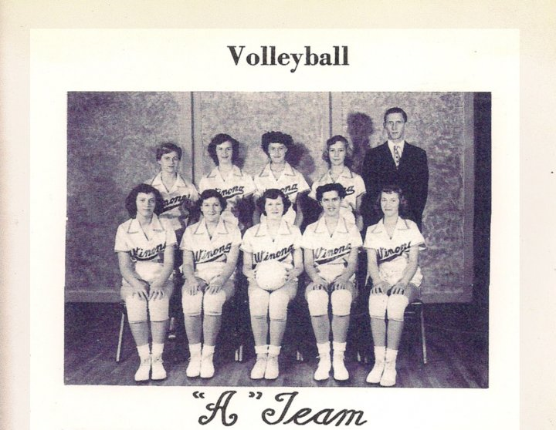

Winona High Volleyball-A Team-1953-54  
Top: Jackie Copeland, Margaret Norton, Peggy West, Beulah Lindsey, Coach Johnny Ledgerwood  
Bottom: Joydell Myers, Bernice Stevenson, Barbara Skaggs, Sandra Millman, Norma Myers

<http://www.facebook.com/profile.php?v=feed&story_fbid=386941765928&id=803360928#!/photo.php?pid=182486&o=all&op=1&view=all&subj=325265558395&aid=-1&id=100000466359880>