[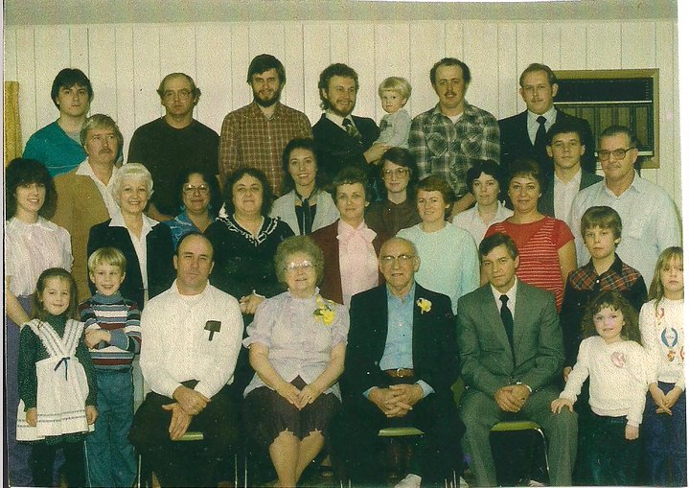](http://www.facebook.com/photo.php?pid=223055&id=100000466359880)

Dennis & Lorene Atkins Myers, 50th Anniversary-2/1985  
(back) Rex Jones, David Banderman, Frank Crownover, Bill Matthews holding Jon, Denny Dixon, Dave Myers,  
(next row) Lori Jones, Loyd Matthews, LaVerne Myers Matthews, Becky Stevenson Banderman, Shannon Myers Jones, Catherine Matthews Crownover, Anita Myers Wakefield, Karen Matthews, Sharon Myers Wilson, Ila Dixon, Norma Myers Stevenson, Dale Wakefield, Al Stevenson,  
(3rd) Angela Crownover, Michael Matthews, Dwain Jones, Lorene Atkins Myers, Dennis Myers, Raymond Wakefield, Davey Banderman, Heather Dixon, Dana Banderman