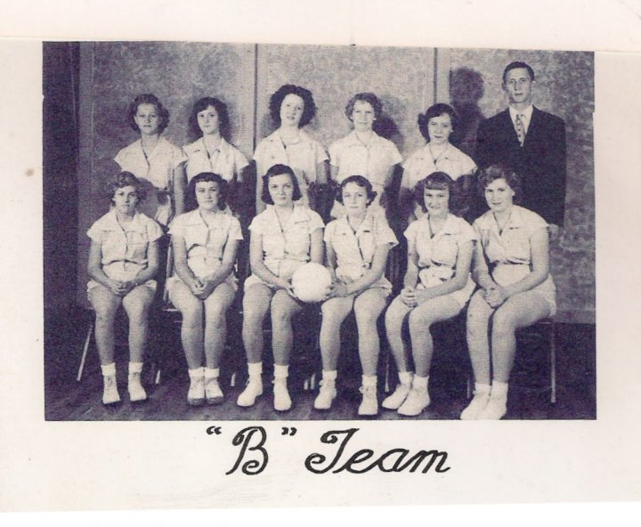

Another one from Winona High, 1953-54. Remember any of them?   
Top: Nedra Atkins, Sue Norton, Evelyn Vermillion, Mary Ellen Fair, Dessie Russell,   
Coach Johnny Ledgerwood.  
Bottom: Dixie Myers, Beth Freese, Carolyn Lovins, Shannon Myers, Judith Freese,   
Dorthena Bland