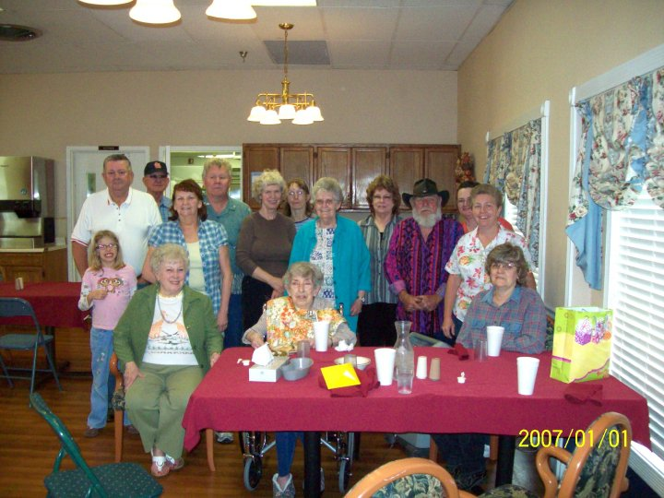

Paul Redman, Gene Yardley, Ethel____, Randy Myers and Lila Hamm Haynes Myers, Barbara George Haynes Brim, Floy Lindsey, Martha Hamm Yardley, Jeep____, Thersa____, Anita____, Rachel Haynes Darlena Goodwin (daughter of Floyd Lee 'Dick' 'Silas' Lindsey), Frances (Cora 'Frances' Jeanette 'Jess' 'Ez' Lindsey) & Carolyn Lindsey Martin Redman.