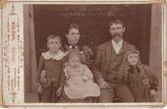

William Oscar Harper, Elizabeth Jane (Klepzig) Harper, David Watson Harper. In front: Cleta & Laura Harper