[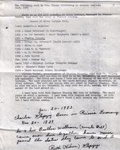](http://www.facebook.com/photo.php?pid=3661097&id=325265558395)

[http://static.ak.fbcdn.net/rsrc.php/z9QLO/hash/8q2anwu7.png](http://www.facebook.com/photo.php?pid=3661095&id=325265558395)

This list shows Charles Klepzig as owner of Alley Mill. My notes say that Charles was the first postmaster at Alley in 1984, and temporarily moved it to his home when the water mill and dam were partially washed out. He was postmaster for 9 years. In 1893 Charles McCaskill bought the mill and became postmaster.