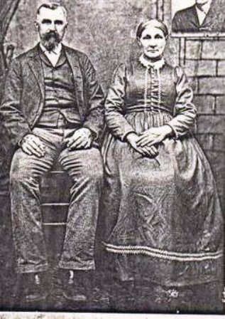

Charles Edward Klepzig   
20 Dec 1839 - 10 Jul 1921  
Born in Prussia Saxony Germany  
&   
Rachel Coulter  
14 Jan 1841 - 19 Apr 1916  
Born in Illinois