[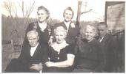](http://www.facebook.com/photo.php?pid=3661097&id=325265558395)

[http://static.ak.fbcdn.net/rsrc.php/z9QLO/hash/8q2anwu7.png](http://www.facebook.com/photo.php?pid=3661095&id=325265558395)

Another Harper family photo. In back: Laura (Cauldwell) Harper & Cleta (Kohler) Harper. In front: David Watson Harper, Izetta (Padrock) Harper, Elizabeth (Klepzig) Harper, William Oscar Harper. Laura and Izetta are also buried in the family plot at Pine Lawn.