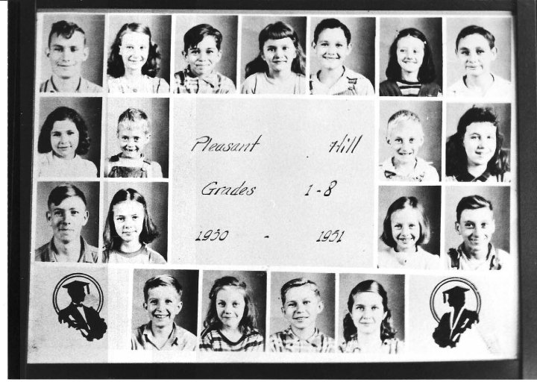

Row 1: Julian Sherrill (Teacher); Elsie Smotherman, Bob Douglas, Faye Douglas, Darrell Bay, Joellen Jones, Junior Bay

Row 2: Kay Bay, Doyle Smotherman, Chester Smotherman, Marguerite Scoville)

Row 3: Bill Barnes, Beulah Barnes, Sue Jones, Tom Smotherman

Row 4: Freddie Gosnell, Jenny Jones, Frank Douglas, Lenora Gosnell.