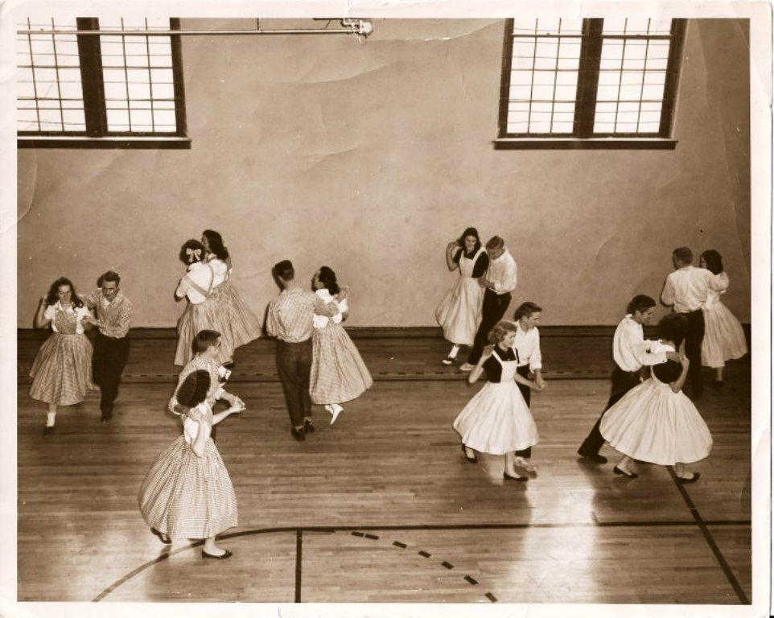

58-59 School year  
Group on the right starting with Joe Davis & Susie Underwood and going counterclockwise, Jerry Daily-Kay Norton, Harry Lovins & Donna Hollis, Jim Stevenson &Patsy McAdams.  
Group on left starting with J.C. Kuesner & _____?, and going counterclockwise one of the Allen twins & Janet Fair, two girls ____? & ____?, Clifford Blunkall & Maxine Stevenson?