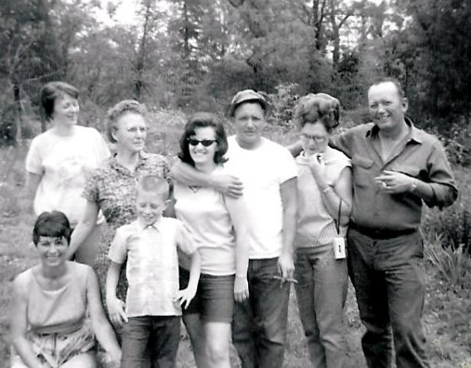

Family get together at Granny Alcorn's home on High School Hill in Eminence, MO: back row - Leah Alcorn Corbin, Minnie Dixon Alcorn, Earlene Rogers Alcorn, Dale "Shot" Alcorn, Alta Alcorn, Bob Alcorn. Front row - Naomi Alcorn Weaver and Stoney Alcorn.

In this photo: Naomi (Alcorn) Weaver, Leah Jean (Alcorn) Corbin, Minnie Pearl (Dixon) Alcorn, Stoney Alcorn, [Earlene Rogers Alcorn](http://www.facebook.com/profile.php?id=1734174662), Dale "Shot" Alcorn, Alta Alcorn, Robert "Bob" Alcorn