**Aunt Charlie, Uncle Daves wife**

  
[Save](http://trees.ancestry.com/pt/ViewPhoto.aspx?pid=&tid=3364832&pg=39,21&tl=1&oid=c922a5e4-b4d5-42ea-ac46-e60a727d56d5&idx=161#Current) or [Cancel](http://trees.ancestry.com/pt/ViewPhoto.aspx?pid=&tid=3364832&pg=39,21&tl=1&oid=c922a5e4-b4d5-42ea-ac46-e60a727d56d5&idx=161#Current)

*Added by* [*sylviarnmlt*](http://www.ancestry.com/community/member/profile.aspx?cba=sylviarnmlt) *on 25 Mar 2008*

[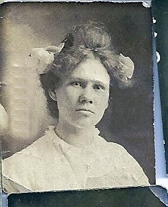](javascript:openOriginalPhoto())

Written on back, Aunt Charlie, Uncle Dave's wife. From the Snider Gaston Lehning Collection. David Ross Snider b 1886 was married to Mary Charles Ely b. 1883. But this photo does not look like other photos of Mary Charles Ely. Any help in identifying this photo would be appreciated. Sylvia Hathaway